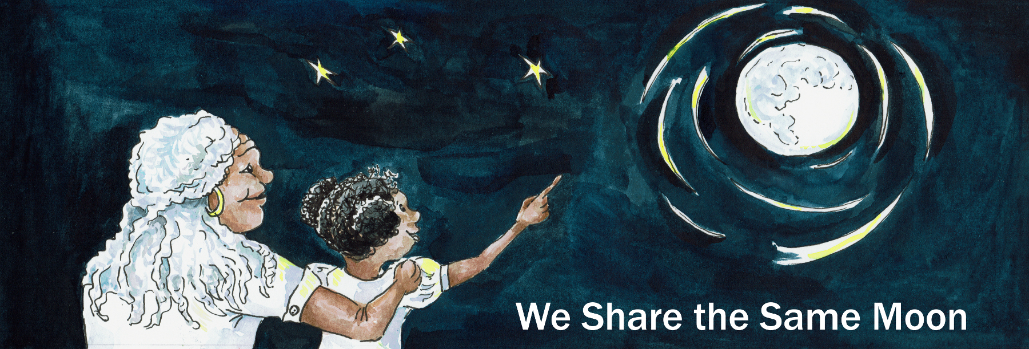
Suggested Age Range: 7 - 8 years: 8 - 9 years; 9 - 10 years; 10 - 11 years
UK Curriculum: Key Stage Two (Upper)
Suggested UK Year Group: Year 6
UK Primary Curriculum Link: Evolution and Inheritance
Science Subject: Evolution
Science Question: How do organisms evolve?
Suggested Science Activity: Evolution
Children with SEND: Use to boost comprehension of science vocabulary
EAL children: For confident older learners
Country of Origin: Israel
Source: King Solomon and the Bee by Dalia Renburg

Long ago, in the country that is now called Israel,

There was a King, no ordinary King but an extraordinary King. King Solomon!
It was said, that he was the wealthiest of all the Kings.
It was said, that he was the wisest of all the Kings.
It was said ,that he was so clever, that he knew all the languages of all the animals in his Kingdom.

King Solomon lived as befits a wealthy King, in the finest of palaces.
Everything was made of gold. Even the taps were made of gold!
His clothes were made out of the finest of silks, with golden threads
And he ate only the finest of food - on golden plates - of course!

One night, King Solomon was lying asleep in his golden bed, with the sheets pulled up to his beautifully brushed head. Only his rather large red nose was visible, snoring gently as he slept. It was summer and the room was filled with roses, and the scent of the flowers wafted around the room. And, at the windows the light of the Moon shone. One of the windows was open and the smell of the roses wafted out.
And a Bee flew into the room is search of those beautiful flowers.
Hungry for food, the bee was overcome with the smell of the roses.
Which one should he drink from first?
He darted from flower to flower, back and forth, so fast he grew dizzy and confused
And then, he made a dreadful mistake! He landed on the Kings nose!
Just as the King let out an enormous snore!
Startled the Bee stung the King. Ting!
The King woke with a tremendous shout. Ouch! “What was that? What was that? Who stung my nose!”
The servants rushed in, swatting the air with enormous fans to try and kill the tiny Bee who had dared to sting the King!

“Stop, stop stop!” cried the Bee. “Please don’t kill me!”
“Why not?” said the King. “I was fast asleep and then you stung me!”

"Oh please, please, please, King, spare me. I meant you no harm. I just got carried away by the smell of all those flowers and I confused your nose for a rose! It was the same beautiful red colour! Please don’t kill me. Who knows - If you save my life - one day I might be able to save yours!”

The King hesitated “ You, a tiny Bee - how can you possibly help me?”
“Well” said the Bee, “Like all Bees, you need me to pollinate all your plants so that you have food to eat”.
“Yes, yes” said the King “I know that! But what else can you do that might be of special use to me, the King?”
“I don’t know” said the Bee. “But if you spare my life, then we can find out!”

The King’s sense of humour finally got the better of him.
In spite of his sore nose, he laughed and laughed. “Foolish Bee, I will spare you.
As you say, who knows, one day I might have need of you!”
"Thank you, thank you, thank you!” said the Bee. And flew as fast as he could out of the window, just in case the King changed his mind.

The years passed. The King grew wealthier.
The palace grew bigger. His rooms filled with the finest of possessions, bought from faraway lands. But there was one thing missing from his life.
One thing he did not possess. One thing he could not buy. Someone.
Someone to love him, someone to marry him. A Queen.
But who could he marry? Which Queen could match him for wealth and for wisdom?
There was no-one and the King lived on alone.

Except …
One day, news came from a far and distant land, in the land we now call Ethiopia, that there lived in the ancient kingdom of Sheba - a Queen.
No ordinary Queen, but an extra-ordinary Queen.
She was said to be the wisest and wealthiest Queen in all the lands, except of course for King Solomon. Could this be true? Could there really be a woman as clever as he?
There was only one thing to do! The King wrote an invitation, asking the Queen to come and visit, to see she would accept the honour of his hand in marriage.

The letter was written, and sent by special envoy in the King’s fastest ship to Africa.
The King waited and waited and waited. At first he was confident that she would say YES.
After all, who would turn down a King such as him?

But, as the weeks and months passed, his confidence wavered.
Maybe, the ship had got lost, maybe the letter had fallen overboard.
Maybe she had received it and refused to marry him! Finally when all hope was gone …

Not one but seven ships were spotted, sailing into harbour, each ship flying the flag of the Queen of Sheba. The letter had arrived safely, she was answering him!
Surely with that many ships - the answer had to be …. Yes?

The King called for his servants and was dressed in his finest of Kingly robes, with a magnificent crown on his curly head, gold, of course!
The ships came into harbour. The King was standing waiting.
The seven ships came to a standstill.
Ropes were thrown, tied and the ships safely secured. The drawbridges were lowered.

And then, down every plank, marched a hundred men.
Soldiers marching in perfect time and perfect step together.
They were all dressed in white and each carried in one hand a white flower. In silence, they marched down the plank and onto the harbour.
In silence, they stood in lines, ten men to a line, line after line after line.
Each man stood stiffly to attention, holding out the flower in one outstretched arm.
None of them made a single sound. Then, the last person came down the plank.
A small boy with a letter in his hand. In silence, he marched up to the King, bowed and handed him the letter. The King opened it and read aloud:

If you want to marry me, then you must win me.
You say that you are the wisest King of all the lands. Then prove it to me!
Each of my men holds a flower. Only one of the flowers is real.
Find the true flower in amongst all these false ones and you will prove your love to me. Choose the real flower - and show me your love is real.
Choose a false flower - and you will never see me again!

The King looked up and sure enough, at one of the windows of the first ship he could see the shadowy shape of a woman. Was it the Queen? Even her shadow looked beautiful! Tt must be the Queen!
But which flower was real? The King thought for a while “Hmmmm”
They all looked the same! How clever! But how confusing!
How could he tell? By smell! Of course!
He walked up and down every line. But, they all smelt the same.
How could this be? Someone must have made a perfume identical to that made by the real flower. How clever! But how confusing!
The King thought for a while “Hmmmm” Touch! Of course!
But as he touched each and every flower, they felt exactly the same
Someone must have spent hours making all the petals look and feel the same.
How clever but how confusing!

But, as the Kings admiration for the cleverness of his chosen Queen increased, his confidence in his ability to out-do her began to wane.
How can I tell which is the real flower? There must be a way!
And slowly, surely he began to realise, that there wasn’t.
The Queen had won! She was cleverer then him!
And that meant, she would not marry him. And he would remain alone.

He stopped, he sighed, he was just about to give up when …
A tiny voice piped up: “Make way for the King’s Bee! Make way for the King’s Bee!”
The King couldn’t believe his ears! The bee! The bee who’s life he had saved so long ago, was back! “Bee, is it possible that you can help me?”
“Sire”, said the Bee. “Many years ago I begged you to save my life
And in return one day I promised to help you if ever my help was needed!
And here I am! Make way for the King’s Bee! Make way for the King’s Bee!"

And the Bee buzzed up and down the lines of men, until at last he landed on one of the flowers. It looked the same, it smelt the same, it felt the same!
But, when the Bee said this was the flower, the King believed him!
The King took the flower, he turned towards the shadow and held it up into the air.
And the shadow smiled! The Bee was right! And the King’s reputation was saved!
The Queen agreed to marry him, and so they lived happily ever after!

Perhaps…

But, how did the Bee know which was the real flower? How could he tell?
Because, to a Bee, all the flowers do NOT look the same.
The Bee has different sight to humans, and they can see shades of light we cannot see. Bees can see ultra-violet light.

What to us, looks like a plain white flower - to a bee can look like a kaleidoscope of colour, that makes a path from the tip of the petals down to heart of the flower and onto the pollen. Many, many flowers use ultralight shades of colour to entice the Bees.
But of course, the King couldn’t see the ultra-violet patterns of colour on the real flower, but the Bee could! And so, a King was fooled, but NOT the Bee!
And that is how a Bee saved a King long ago! Or at least - thats what I was told!

Copyright: Cassandra Wye May 2019

